**Integrated Academy Setup**

1. Check if you have already install the **XAMPP Serve**r if this server is already installed, Run the **XAMPP Server** then start the **APACHE** and **MYSQL**

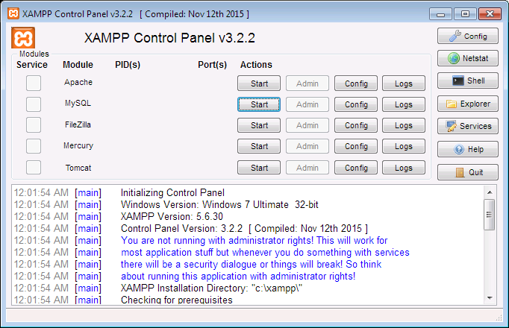

* **Figure 1**

1. Copy your zip file named **IAS.zip** or **IAS.rar**

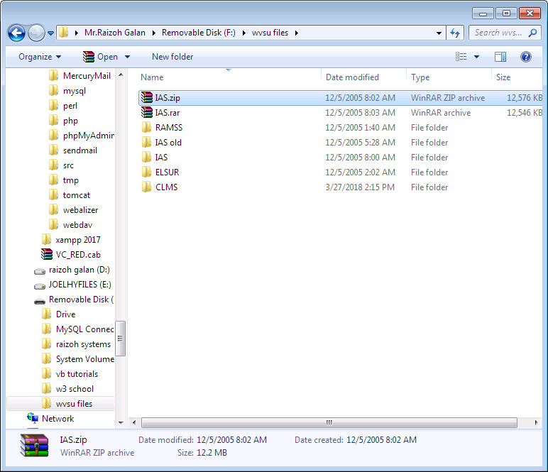

* **Figure 2**

1. Then paste the file in xampp folder by clicking the **Explorer** button in **XAMPP Control Panel** file explorer will be showed like in **Figure 4** , paste the file inside the folder of **htdocs**

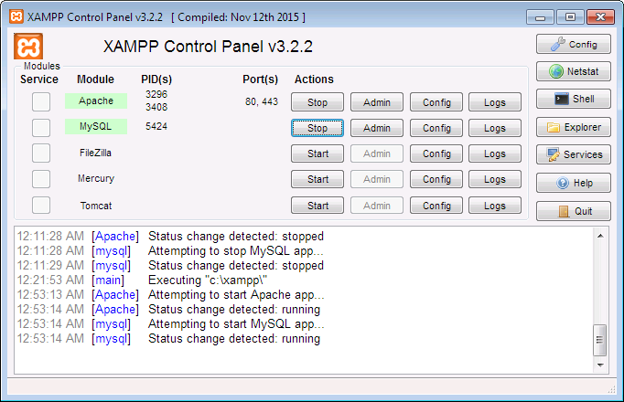

* **Figure 3**

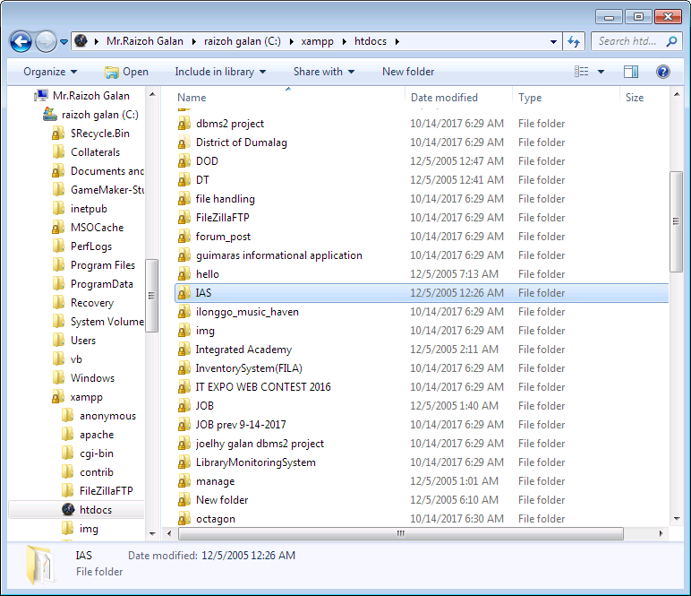

* **Figure 4**

1. If you done pasting the file its time to unzip it by clicking the file **IAS.zip** or **IAS.rar** then right click the file and choose **Extract Here** file
2. 
3. If you done copying the file it’s time to import the database. Go back to **XAMPP Control Panel** and click the **Admin** of **MYSQL** the browser will open and **PhpMyAdmin** page will load



1. Click **New** to create new database

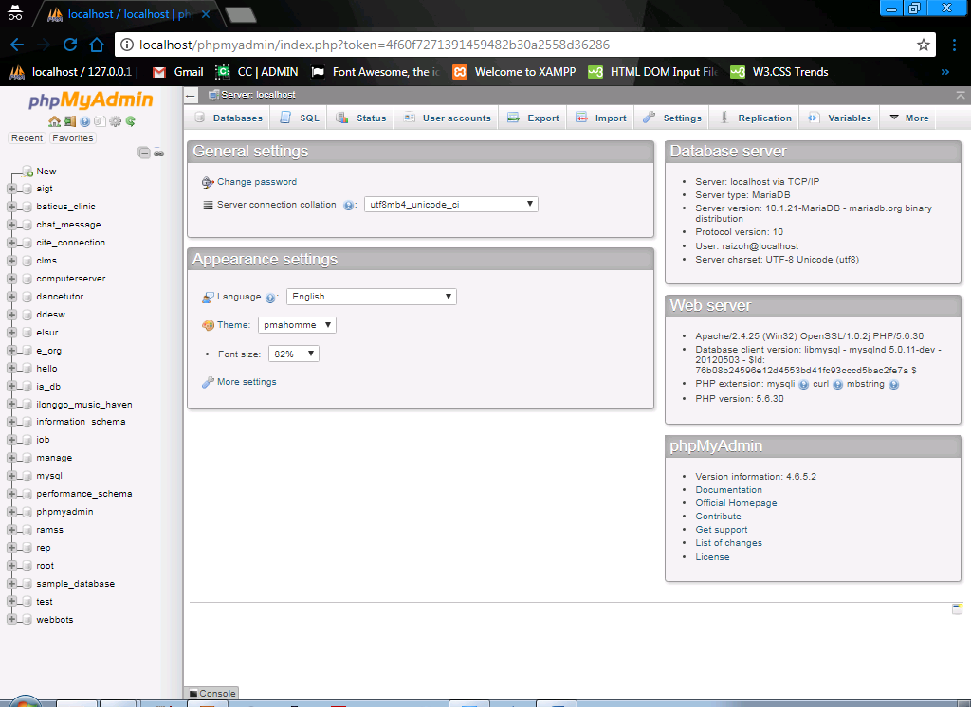

1. Create database named **ia_database** and click **Create** button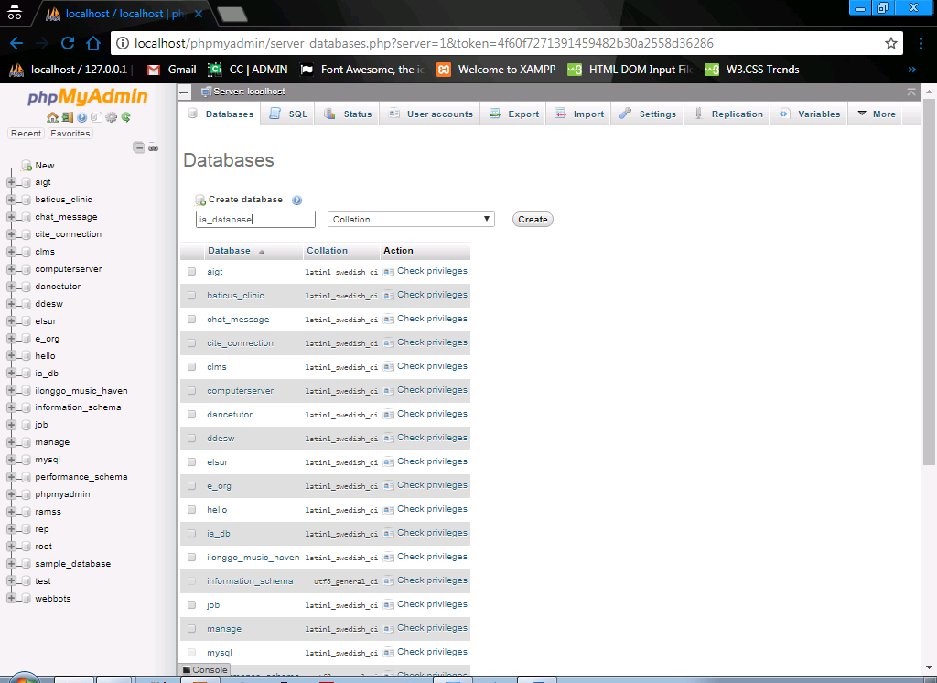
2. After clicking **Create** button new page will load now you can **Import** your database by clicking the **Import** button it will redirect you to new page

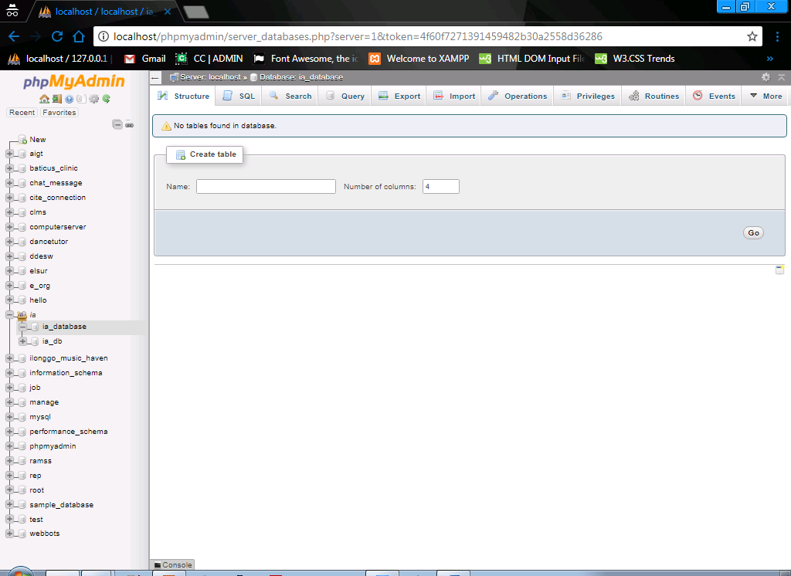

1. Click **Choose File** button and browse your file inside the **IAS** folder, select the file named **ia_database.sql** inside your **IAS** Folder if you done selecting the file click **Go** button to import 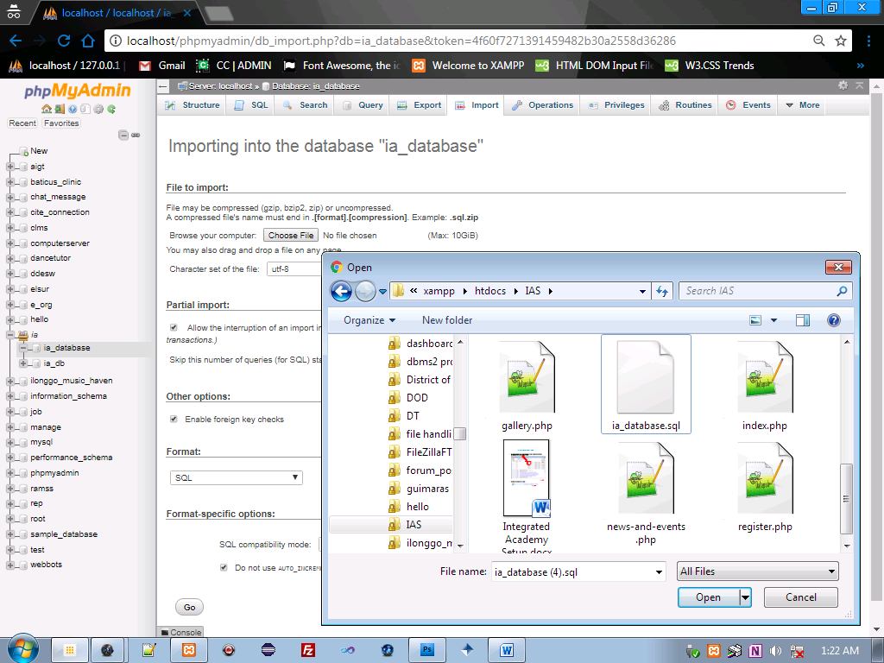
2. Now you can access the page by writing <http://localhost/IAS>

**Links**

* <http://localhost/IAS/admin> for admin login
  + **Default Account for Admin**
    - **Username** = admin
    - **Password** = admin
* <http://localhost/IAS/faculty> for faculty login
* <http://localhost/IAS/> for student and parent page you will see the **Login** Button it will show modal for student login

**--------------------------------------------Thank You -------------------------------------------**